

Media database

John Michael Pasiolan, Andrew Shahini, Danat Muradov



November 29, 2024

Application development

Vanier College

Table of Contents

Project Description 3

UML Diagram 4

Program Features and Screenshots 5

Functionalities 5

Expected Output 5

Login Form 6

Description: 6

Features: 6

Error Messages: 7

Create Account Form 7

Description: 8

Features: 8

Error Messages: 8

Payment Form 11

Description: 12

Features: 12

Error Messages: 12

Main Menu Form: 14

Description: 15

Features: 15

Profile Form 15

Description: 16

Features: 16

Watchlist Frame: 16

Description: 17

Features: 17

BackButton: Back button to go back to the previous page. 17

LanguageButton: Switch the language from English to French and vice versa. 17

MediaLoadFrame: 17

Description: 18

Features: 18

CrewMemberFrame: 18

WriteAReviewFrame: 18

ViewReviewsFrame: 19

19

Challenges 20

Learning Outcomes 21

# Project Description

Our project is a movie system that allows the user to sign in as a client to search through a database of films. The system will allow the user to create an account and pay for a premium membership or keep the regular membership. The premium membership will have access to the recommendation engine that generates movies that seem appealing for the user in reference to their search history and their preferences. Premium members will also be able to view the best actors around the world and can comment on their performance as many times as they want to. In contrast, the regular membership has a limit of 5 comments on their account just for movies and Tv shows. In addition, the interface will allow the client to search for their favourite movies based on the directors, actors, genre, and title. Our project will also allow the client to add movies to their watchlist, see the reviews that movie critiques leave on the film. Furthermore, the user can leave their own review on the different media, actors and even directors by giving it a rating and comment.

# UML Diagram

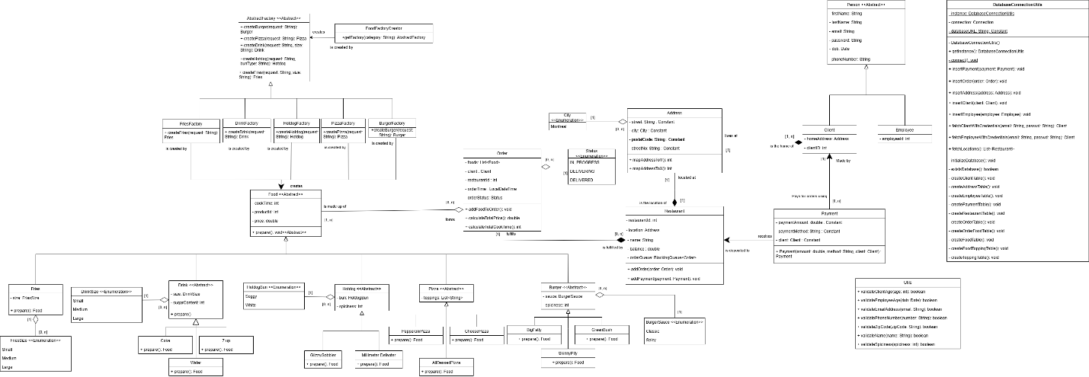

# Program Features and Screenshots

## Functionalities

* Fetching and filtering movie information such as title, genre, and rating from the movie database.
* Add movies to the user’s watchlist.
* The user can rate and review media, which are stored in the database.
* Premium members can give a rating to the actors and directors of their choice.
* Recommendation engine that generates based on their watchlist.
* The user has to create an account and log in to our system.
* The user can upgrade their membership to premium by paying online.
* The user interface can be provided in English and French.
* Making a payment to upgrade the user’s membership.

## Expected Output

* The interface should be displayed in English or in French based on the user’s choice.
* The login page should be refused if the user does not have an account and granted if they do have an account.
* The interface will update the user’s watchlist after adding or removing a movie.
* The interface will match the search or filter and return a list of media.
* Display details about a specific movie.
* Regular members can upgrade their membership to premium to get access to the recommendation engine based on the user’s activity preferences.
* Adding and fetching movie ratings and reviews from the database.
* Display a top 10 list of the best movies and tv shows for the premium members.

## Login Form

### Description:

In the Login form, you can log in into your account if you already have one. If you don’t you can click on the Create Account button to create an account.

### Features:

* + Language button that allows you to switch language. It will make all the words in the form turn into French.
  + Login button that allows you to login into your existing account.
  + Create Account button that allows you to create a new account if you do not already have one.

### Error Messages:

**All error messages in the application have a French translation.**

**If the login information is invalid:**

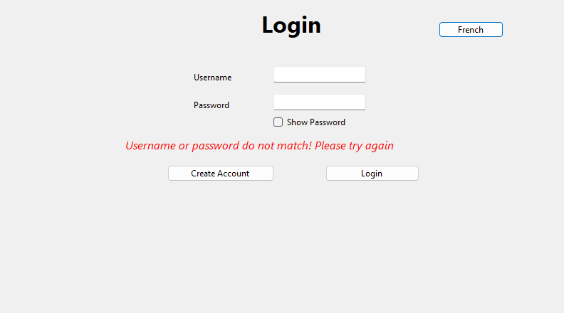

## Create Account Form

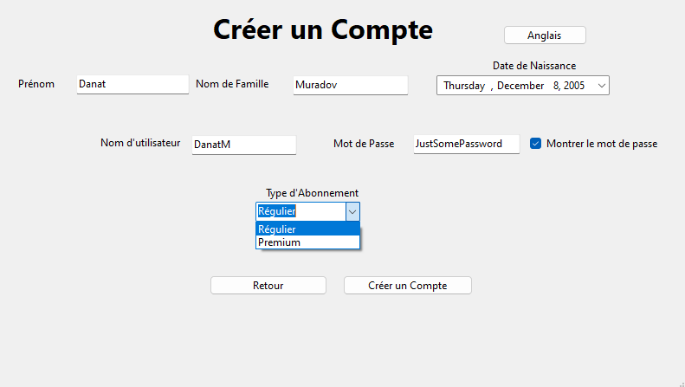

### Description:

You can create your new account in the Create Account Form. Choose between Regular and Premium memberships. Depending on which membership you pick, you will either pay for the premium or it will automatically be made if you pick the regular version.

### Features:

* + Language button that allows you to switch language. It will make all the words in the form turn into French.
  + Back button that allows you to go back to the previous form (Login Form)
  + Show Password checkbox that allows you to see the password when it is checked.
  + Date Box to choose your birthday accurately.
  + Pay button that will bring you to the payment form to pay for your premium Account
  + Create Account that will bring you to the main menu form.

### Error Messages:

**If the first name is invalid:**

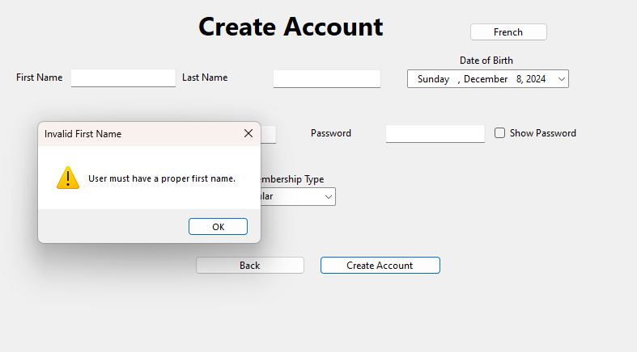**If the last name is invalid:**

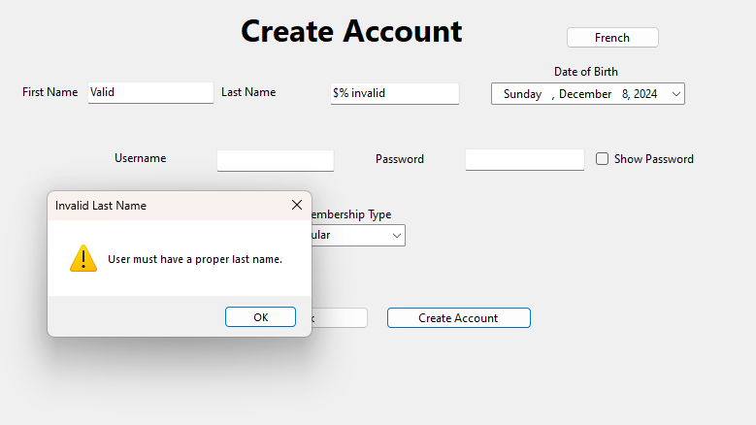

**If the user’s age is less than 18:**

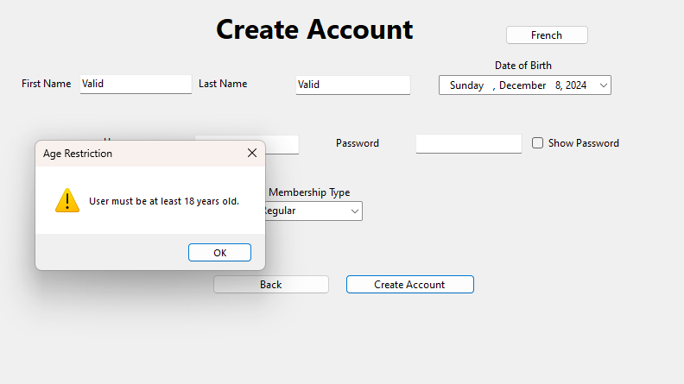**If the user’s username is invalid:**

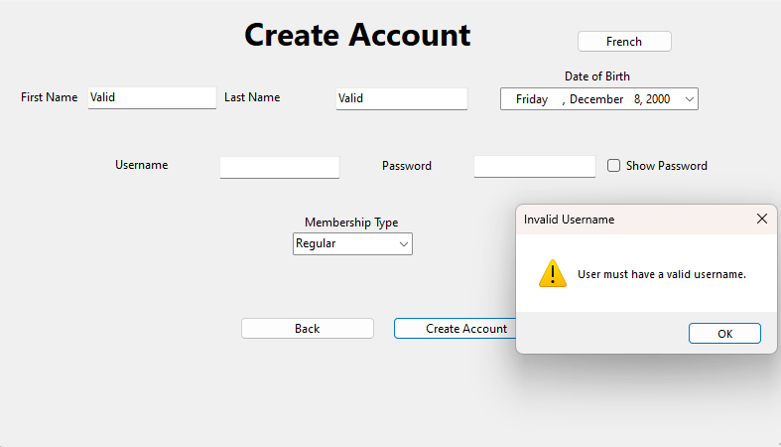

**If the user’s password is invalid:**

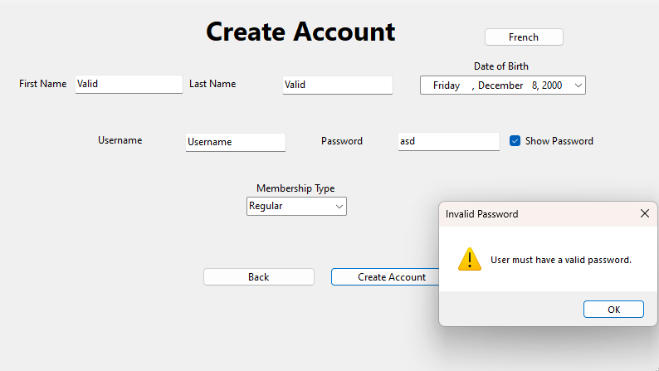

## Payment Form

### Description:

If you have chosen the premium membership in the create account form, it will bring you to the payment form. In the payment form, you get to pay for the membership by putting in your card information in the available boxes.

### Features:

* + A pay button. When clicked, it validates your card, and once it has been verified and everything is all good, it will pay.
  + -When clicked, the back button returns you to the create account form. So, if you ever change your mind, the back button is always available.

### Error Messages:

**If the card holder name is invalid:**

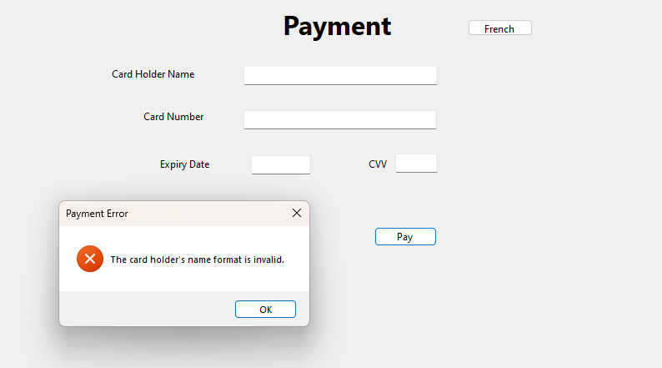

**If the card number is invalid:**

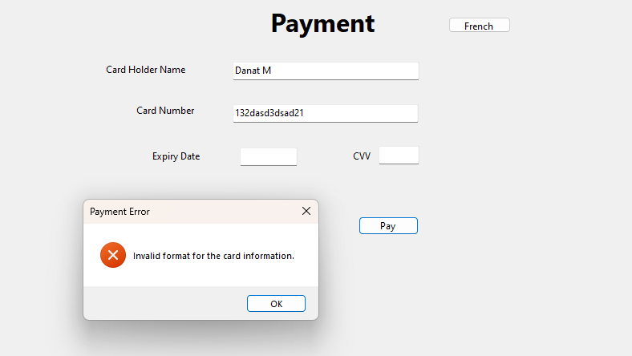

**If the expiration date if invalid:**

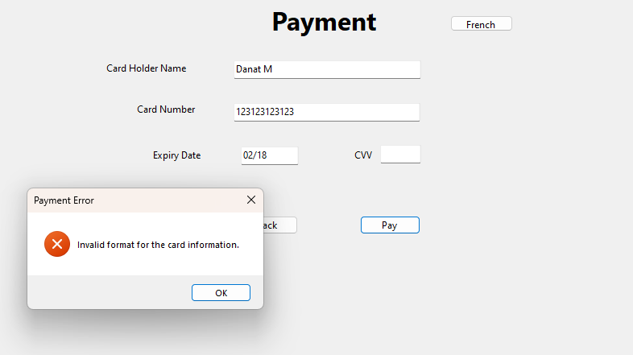

**If the CVV is invalid:**

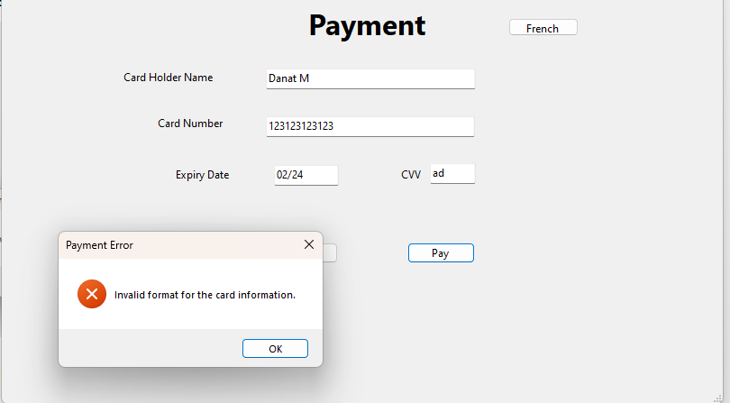

## Main Menu Form:

### Description:

You can scroll through the list of movies within the database. If you want to view more information about the movie, you can click on it to bring you to another frame with the description of the movie. There are multiple movies and multiple TV shows within the system. You can type the movie you are looking for in the search bar. You can pick the type of genre of movie you want by clicking on the box with the arrow pointing down.

### Features:

* + Recommendation Button: Lists movies recommended for you based on your watchlist
  + Top 10 button: Shows the top 10 most popular movies.
  + Movies Button: Lists only movies
  + TV show Button: Lists only TV Shows
  + Genre Box: Multiple genres users can choose from to search for movies with that genre.
  + Search box: To search for a specific movie or TV show.
  + Username button: To go to Profile Frame.
  + Language Button: To switch the language to French, or English.

## Profile Form

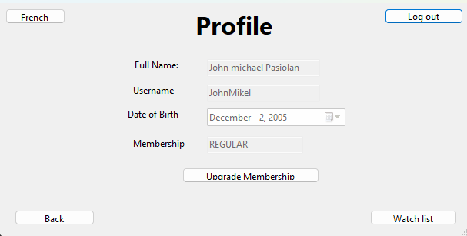

### Description:

The Profile Form is straightforward. It allows you view your profile details, so your full name, username, date of birth, and membership. You can always upgrade your membership whenever you want, and you can view your personal watchlist.

### Features:

* + Language button, so you can switch to English or French.
  + A logout button, so you can log out of your account whenever.
  + An upgrade membership button, for when you want to purchase the premium version of the membership to access more features.
  + A back button to return to the main menu.
  + A watch list button, to view your watch list.

## Watchlist Frame:

### Description:

In the watch list form, you are able to view the movies you want to watch in the future. You added them from the MediaLoadFrame when you clicked on the add to watchlist button.

### Features:

1. BackButton: Back button to go back to the previous page.
2. LanguageButton: Switch the language from English to French and vice versa.

## MediaLoadFrame:

### Description:

In the MediaLoadFrame, you are able to view the description of the movie you clicked. You are can see the director and the actors of the film, the genre of the movie, and the date it released. This is the page where you can leave reviews and view your reviews by clicking on the write review button and the view review button. You can also add the movie to your watch list by clicking on the add to watchlist box. By clicking on the actor’s or the director's photos, you will go to crew member frame where you can leave a review on the director or actor and view the movies they are in or directed. For the tv shows, you can leave a review on the tv show as a whole, but if you click on an episode, you can leave a review on a specific episode of a tv show.

### Features:

1. Back button: To go to previous page
2. Language Button: To switch language from English to French and vice-versa.
3. Write a review button: Brings you to the WriteAReviewFrame to leave a review for the movie.
4. View reviews button: Brings you to the ViewReviewsFrame to view the reviews you made for the movie.

## CrewMemberFrame:

### Description:

In the CrewMemberFrame, you are able to view a list of movies that the actor is in. If it a director, you are able to view a list of movies that the director directed. You can leave a review on the actor or director by clicking on the write a review button. You can view the review on the actor or director by clicking on the view reviews button.

### Features:

1. Back Button: To go the to previous page.
2. Language Button: To switch language from English to French and vice-versa.
3. Write a review button: To leave a review on the actor or director.
4. View review button: To view the reviews that you have left on the actor or the director.

## WriteAReviewFrame:

### Description:

In the WriteAReviewButton, You are able to leave your review on the movie that you have selected, on the actor you selected or on the director you selected. There is a rating box where you can leave your rating out of 5. There is a comment box where you can leave your review. When you click on the Post button it will leave your review on the system.

### Features:

1. Back Button: To go the to previous page.
2. Language Button: To switch language from English to French and vice-versa.
3. Post Button: To leave your review on the system.

### Error Messages:

If you do not leave a review out of 5.

## ViewReviewsFrame:

### Description:

In the ViewReviewsFrame, you are able to view the reviews that you have already left.

### Features:

1. Back Button: To go to the previous page
2. Language Button: To switch language from English to French and vice-versa

# Challenges

* We had challenges with our time management.
* The I18N for the genres to switch between French and English.
* Loading images in the main menu.
* Implementing a fully functional database.
* Debugging

# Learning Outcomes

* We learned how to write proper commit messages in GitHub.
* Database integration
* Work efficiently as a team
* Added I18N to an application.
* Designing GUIs that are user friendly.